Composite Materials - Metal Matrix Composite

Institute for Engineering Research and Publication (IFERP) organized a webinar on Composite Materials - Metal Matrix Composite, on September 20th, 2020 at 5:00PM (IST) on webinarjam. This webinar focuses on the Materials used in the Process other than the metal. This Webinar will Help the Participants who are Studying and Doing Research on Metal Matrix Composite.

Speaker
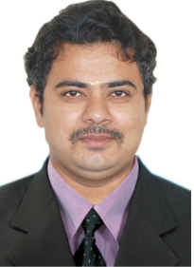

Dr. B. Radha Krishnan

Assistant professor,

Department of Mechanical Engineering,

Nadar Saraswathi College of Engineering and Technology

India.

The Keynote Speaker broadly discussed the uses and advantages/disadvantages of Biology in Concrete.

Highlights of the Webinar:
E-certificate was provided to all attendees.
Free IFERP membership was provided to all attendees with membership certificate.
Telecasted Live on YouTube.
YouTube Channel Link: https://www.youtube.com/watch?v=krt5AIybE1s
The webinar was attended by more than 200 attendees and viewed live by more than 5000 subscribers on YouTube.

